NAME:………………………………………. ……………CLASS:………….
ADM NO: ………CLASS: …………… DATE: ……………………………………………..
CANDIDATE’S SIGNATURE…………………….
ARISE AND SHINE TRIAL 2
CHEMISTRY PAPER 233/2- (THEORY)
JULY 2026
TIME:2 HOURS

Instructions to candidates.
- Write your full name and Index number in the spaces provided above.
- Sign and write the date of examination in the spaces provided above.
- Answer all questions in the spaces provided.
- All working must be clearly shown where necessary.
- Scientific calculators may be used.

FOR EXAMINER’S USE ONLY
Question | Maximum score | Candidate’s score
1 | 11
2 | 11
3 | 11
4 | 12
5 | 13
6 | 11
7 | 11
TOTAL | 40

1. The table below is part of the periodic table. Study it and answer the questions that follow. The letters do not represent the actual symbols of the elements.

A |  |  |  |  |  |  | A | B
C |  |  |  |  |  | D | E | F
 |  |  |  |  |  | G | H | I
K | L |  |  |  |  |  | M | J
(a). From the table above chose
(i) The largest atom ……………………………………………………………………………. (½ mark)
(ii) Lightest atom ………………………………………………………………………………. (½ mark)
(b). Explain why the position of element A can e put under groups in which element C and E belong.( 2 marks)
………………………………………………………………………………………………………………
………………………………………………………………………………………………………………..
(c). Give the electron configuration of the ions formed by D and L. (1 mark
……………………………………………………………………………………………………………………….
(d). Give the formula of an Ion with an electron arrangement 2.8.8 that is
(i). Negatively charged. (½ mark)
………………………………………………………………………………………………………………………..
(ii) Positively charged. (½ mark)
…………………………………………………………………………………………………………………………
(e) Explain why J has a higher melting point than B. (2 marks)
…………………………………………………………………………………………………………………………
…………………………………………………………………………………………………………………………
…………………………………………………………………………………………………………………………
(f) Under which chemical families would you place the following elements?
K…………………………………………………………………………………………. (½ mark)
M ………………………………………………………………………………………… (½ mark)
(g) (i) The atomic mass of I is 39.948. Why is it NOT a whole number? (1 mark)
…………………………………………………………………………………………………………………….
(ii) What is the composition of the nucleus of an atom of element I? (Assume the atomic mss of I is 40). (1 mark)
………………………………………………………………………………………………………………………….
(iii). Draw the structure of atom I. (1 mark)

2. The diagram below shows a setup that can be used to obtain nitrogen gas in an experiment.
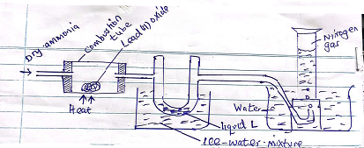
(a)(i). Name liquid L. (1 mark)
………………………………………………………………………………………………………………………..
(ii). State and explain the observation that would be made in the combustion tube after heating for some time.
(2 marks)
.....................................................................................................................................................................................
……………………………………………………………………………………………………………………….
(iii). Write an equation for the reaction that took place in the combustion tube. (1 mark)
……………………………………………………………………………………………………………………….
………………………………………………………………………………………………………………………..
(iv). If 320cm² of ammonia gas reacted completely with Lead (II) oxide) pb=207 molar gas volume = 24000cm³)
Calculate
I Volume of nitrogen gas produced. (1 mark)
……………………………………………………………………………………………………………………….
II Mass of Lead (II) oxide that reacted. (3 marks)
………………………………………………………………………………………………………………………..
……………………………………………………………………………………………………………………………………………………………………………………………………………………………………………………
(b) What observation would you make when
(i) Blue litmus solution is added to water in the beaker at the end of the experiment
Explain. (2 marks)
………………………………………………………………………………………………………………………………………………………………………………………………………………………………………………………………………………………………………………………………………………………………………………
(ii) Write a balanced equation for the reaction between calcium hydroxide and ammonium chloride solution.
(1 mark)
........................................................................................................................................................................................
3 The standard electrode potentials of the elements chlorine and magnesium are:
Cl_{2(g)} + 2e⁻ $→$ 2cl⁻_{(aq)} ${ E}^{θ}$= +1.36v
${Mg}^{{2+}_{(aq)}}$ + 2e⁻ $→$Mg(s) ${ E}^{θ}$ = -2.36v
(a)(i) Which one of the two elements will act as an oxidising agent? Explain. (1 mark)
………………………………………………………………………………………………………………………….

(ii). Calculate the electromotive force of a cell where the overall reaction is (1 mark
${cl}_{2_{(g)}}$ + Mg_{(s)} $→$Mg${Cl}_{2_{(aq)}}$
…………………………………………………………………………………………………………………….
(b) The table below gives the standard electrode potentials of divalent metals represented by the letters P, Q, R and S (not their true element symbols) Use them to answer the questions that follow.
Metal | $$E^{θ}$$
P  Q  R  S | + 1.50  -0.44  +0.34  -0.76

(i) Which one of the metals cannot be displaced from a solution of its ions by any of the other metals in the table? (1 mark)
………………………………………………………………………………………………………………………..
(ii) Metal P and Q were connected to form a cell as sown in the diagram below.
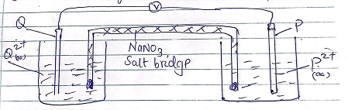
I On the diagram label the metals P and Q and indicate the Ions in solutions. (2 marks)

II Write half equations for the reactions taking place at the electrodes. (2 marks)
P
Q
III State two functions of the salt bridge. (1 mark)
………………………………………………………………………………………………………………………..
………………………………………………………………………………………………………………………..
(IV) What must be observed about the choice of the salt bridge? (1 mark)
…………………………………………………………………………………………………………………………
(v) Write a conventional representation of the cell. (1 mark)
…………………………………………………………………………………………………………………………
(iii) A metallic couple of the metal S and Z produced a voltage of +1.71v (Assume that S has more negative standard electrode potential)
I Calculate the standard electrode potential (SEP) for metal Z. (1 mark)
……………………………………………………………………………………………………………………………………………………………………………………………………………………………………………………
II Arrange the metals P, Q, R and Z in their decreasing order of reactivity. (1 mark)
………………………………………………………………………………………………………………………..

(4) Study the flow chart below and answer the questions that follow.
i Name the process that is taking place in step I. (1 mark)
…………………………………………………………………………………………………………………………
ii Describe the chemical test that can be carried out to show the identity of organic compound A. (2 marks)
………………………………………………………………………………………………………………………………………………………………………………………………………………………………………………………………………………………………………………………………………………………………………………
iii Give the name of the following. (2 marks)
I A-
II B -
iv Give the structural formulae of substance C . (1 mark)
………………………………………………………………………………………………………………………….
v Name the type of reaction that occurs in (2 marks)
I step IV…………………………………………………………………………………………………………….
II Step VI …………………………………………………………………………………………………………..
vi Give the reagent and condition necessary for step VI
Reagent……………………………………… (1 mark)
Condition ……………………………………… (1 mark)
(b) Give the systematic names of the following compounds
I CH₃CHCHCH₂CH₃ (1 mark)
…………………………………………………………………………………………………………………..
II CHCCH₃ (1 mark)
…………………………………………………………………………………………………………………..
5. The diagram below shows chromatograms for five different dyes
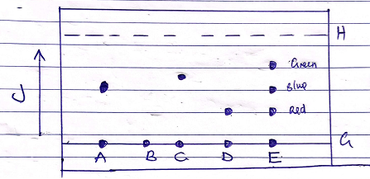
(a). Name the method of separation illustrated above. (1 mark)
…………………………………………………………………………………………………………………..
(b). What conditions are required to separate the chromatograms in a dye? (2 marks)
……………………………………………………………………………………………………………………………………………………………………………………………………………………………………………………
(c). What is meant by the term solvent front?
Indicate its position in the diagram. (1 ½ marks)
……………………………………………………………………………………………………………………..
(d). which letters represent?
i Base line …………………………………………………………………………………………………..(½ mark)
ii solvent path ……………………………………………………………………………………………… (½ mark)
(e) Which chromatogram was present in dye E? (1 mark)
………………………………………………………………………………………………………………………….(f) Which dye is insoluble? (½ mark)
…………………………………………………………………………………………………………………………(g) Which dye is pure? Explain. (2 marks)
…………………………………………………………………………………………………………………………………………………………………………………………………………………………………………………… (h) Which chromatogram is most soluble? Explain. (1 mark)
……………………………………………………………………………………………………………………………………………………………………………………………………………………………………………………
(i) How can one obtain the extract of the blue dye? (1¹/₂ mark)
…………………………………………………………………………………………………………………………
(j) The result showed that dye E contained unwanted colour. Identify the colour. (¹/₂ mark)
…………………………………………………………………………………………………………………………
(k) State one application of the above method of separation. (1 mark)
…………………………………………………………………………………………………………………………
(6) (a) Use the information below to answer the questions that follow
Ca_{(s)} + ¹/₂O_{2(g)} $→$ CaO $∆$H = -635KJ/mol
Ca_{(s} + O_{2(g)} $→$ CaO_{(s)} $∆$H = -394KJ/mol
Cu_{(s)} + C_{(s)} + ³/₂O_{2(g)} $→$ CaCO₃ $∆$H = -1207KJ/mol

Calculate the enthalpy change for the reaction (3 marks)
CaO_{(s)} + CO_{2(g)} $→$ CaCO_{3(s)}
(2 marks)
…………………………………………………………………………………………………………………………. ………………………………………………………………………………………………………………………….
………………………………………………………………………………………………………………………… ..………………………………………………………………………………………………………………………..
(b) The following data was obtained during an experiment to determine the molar heat of combustion of ethanol
Volume of water used= 50cm³
Initial temperature of water = 25ºc
Final temperature of water = 44.5ºc
Mass of ethanol + lamp before burning = 121.5g
Mass of ethanol + lamp other burning = 120.0g

Calculate the
(i) Heat evolved during the experiment (density of water = 1g/cm³, specific heat capacity of water = 4.2J/g/k,
(1 mark)

(ii) Molar heat of combustion of ethanol (C=12,O=16,H=1) (2 marks)
……………………………………………………………………………………………………………………………………………………………………………………………………………………………………………………………………………………………………………………………………………………………………………….
(c) Write the thermo equation for the complete combustion of ethanol. (1 mark)
…………………………………………………………………………………………………………………………
(d) At 298k and one atmosphere pressure, graphite changes into diamond according to the equation

C_{graphiter} C_{diamond} $∆$H = +2.9kj/mol
In the space provided sketch a simple energy level diagram for the above change. (2 marks)

(e). Study the information in the table below then answer the questions that follows
Bond | Bond energy(KJ/mol)
H-H  Cl-Cl  H-Cl | 435  243  431

Calculate the enthalpy changes for the reaction
H_{2(g)} + Cl_{2(g)} $→$ 2HCl_{(g)} (2 marks)
…………………………………………………………………………………………………………………………………………………………………………………………………………………………………………………………………………………………………………………………………………………………………………………………………………………………………………………………………………………………………………
7. Sodium thiosulphate solution reacts with dilute hydrochloric acid according to the following equation
S₂O₃²⁻ + 2H+ $→$H₂O_{(l)} + SO_{2(g)} + S_{(s)}

In an experiment to study how the rate reaction varies with concentration, 10cm³ of 0.4M sodium thiosulphate was mixed with 10cm³ of 2M hydrochloric acid in a flask. The flask was placed in a white paper marked with cross x. The time taken for the cross x to become invisible when viewed from above was noted and recorded in the table below. The experiment was repeated three times at the same temperature using the volumes in the table and the results recorded as shown in the table below.

Experiment | Volume of 0.4M thiosulphate (Cm³) | Volume of water | Volume of 2M Hcl cm³ | Time (sec)
1  2  3  4 | 10  7.5  5.0  2.5 | 0  2.5  5.0  7.5 | 10  10  10  10 | 16  23  32  72
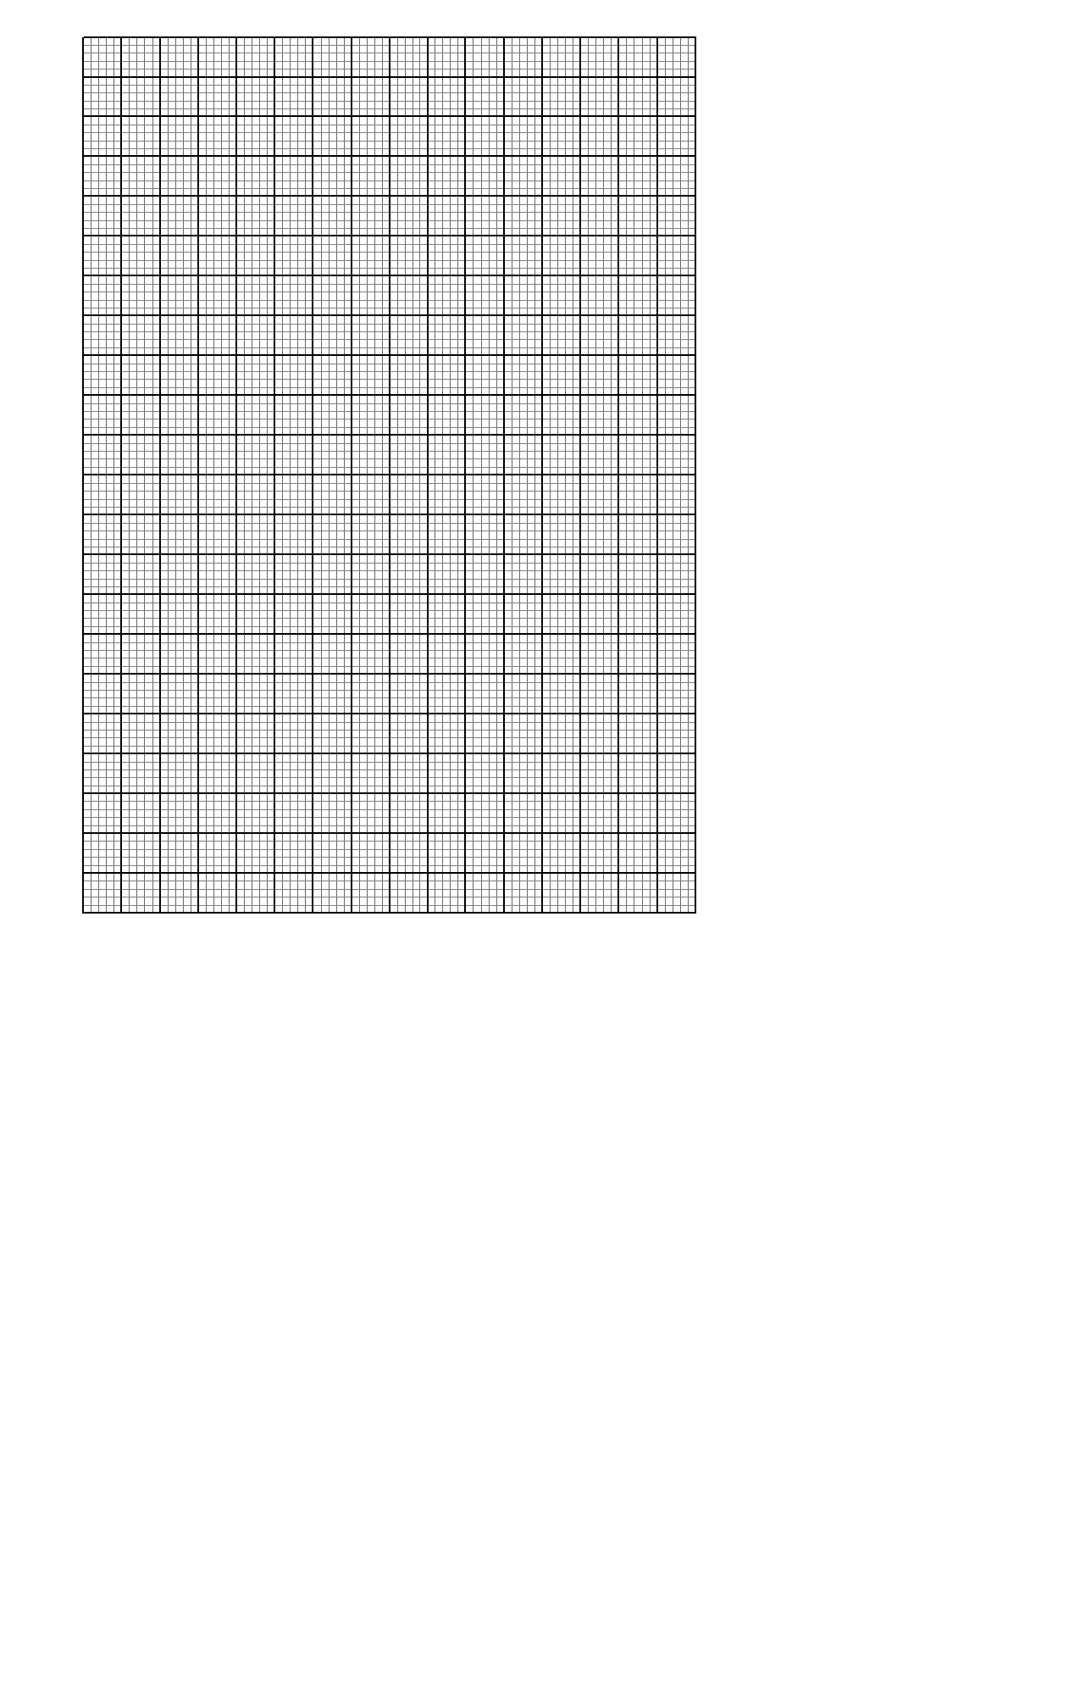
a(i) on the grid below plot a graph of the volume of thiosulphate (vertical axis) against time taken for the cross (x) to become invisible. (3 marks)

ii From the graph determine how long it would take for the cross to become invisible if the experiment was done

I Using 6cm³ of the 0.4M thiosulphate (1mark)
……………………………………………………………………………………………………………………………………………………………………………………………………………………………………………………

II Using 6cm³ of 02M thiosulphate solution. (1 mark)
……………………………………………………………………………………………………………………………………………………………………………………………………………………………………………………
b Using values for experiment I calculate
i Moles of thiosulphate used (1 mark)
…………………………………………………………………………………………………………………………………………………………………………………………………………………………………………………….
ii Moles of hydrochloric acid used. (1 mark)
…………………………………………………………………………………………………………………………………………………………………………………………………………………………………………………….iii Which of the two reactants in experiment controlled the rate of the reaction Explain. (2 marks)
…………………………………………………………………………………………………………………………………………………………………………………………………………………………………………………….
…………………………………………………………………………………………………………………………………………………………………………………………………………………………………………………….
c Give two precautions which should be taken in experiment 1;2,3 and 4? Explain. (2 marks)
…………………………………………………………………………………………………………………………………………………………………………………………………………………………………………………….
…………………………………………………………………………………………………………………………………………………………………………………………………………………………………………………….

